The Product Service Code Selection Tool
A Navigational Guide

Contents
I. Introduction 3
II. Accessing the PSC Selection Tool 4
III. Searching For PSCs 5
A. Search Function 5
B. Spend Categories 6
C. Object Class Code 8
D. Better Buying Portfolio 9
IV. References 11
V. Contact 12
VI. APIs/Integration 13
VII. Conclusion 14

I. Introduction

A Product Service Code (PSC) is a code that describes products, services, research, and development purchased by the federal government. These codes indicate what the government has purchased for each contract action, and these purchases are tracked in the Federal Procurement Data System.

The PSC Selection Tool has been designed to help the federal procurement and finance communities properly identify what they are buying on contracts. The tool allows users to search for the correct PSC by keyword search, code search, or using the Federal Government’s spend categories. These categories, as established by the General Services Administration (GSA), group together like products or services to enable the government to buy smarter and more like a single enterprise, delivering more savings, value, and efficiency for Federal Agencies. The tool also allows searches by the Department of Defense’s (DOD’s) legacy 16 portfolio groups: nine services groups and seven products groups.
The PSC Selection Tool provides users with additional useful information about each PSC including the PSC to the Object Classification Code (OCC) outlined in the PSC-to-OCC crosswalk (updated for fiscal year 2018) and suggested North American Industry Classification System (NAICS) code for many PSCs.
Use of the PSC Tool will assist the procurement and financial management communities in properly representing the good or service being purchased, and thereby improve contract and spend data quality.

II. Accessing the PSC Selection Tool

To obtain PSC data, the user can access the PSC Selection Tool at https://psctool.us. An image of the home page can be found below (Figure 1). The PSC website does not require any login specifications.

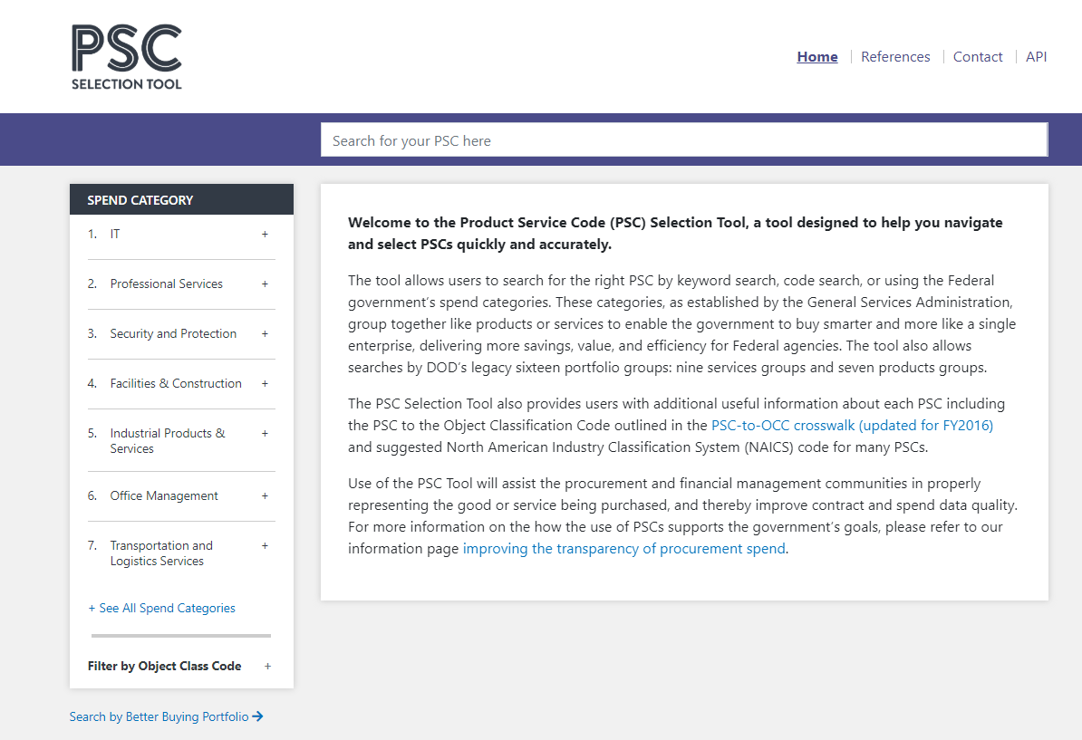

Figure 1: PSC Selection Tool Landing Page

From this page, the user may search for a PSC by keyword or search code. Alternatively, the user may navigate to it by using Spend Category, OCC, or Better Buying Portfolio group.

III. Searching For PSCs

A. Search Function

Once the user has accessed the main page, he or she may search for a PSC by using the search bar at the top of the screen (Figure 2a).

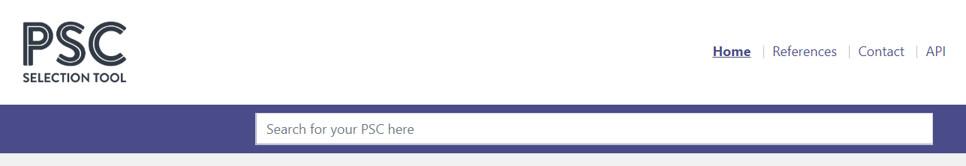

Figure 2a: PSC Selection Tool Search Bar

The user may search for a PSC by keyword, where a list of PSCs related to the keyword will appear. Alternatively, the user may perform a code search by entering a PSC’s four digit classification number. Figure 2b provides an example of a keyword search while Figure 2c provides an example of a search by a PSC’s four digit classification number (see figures below).

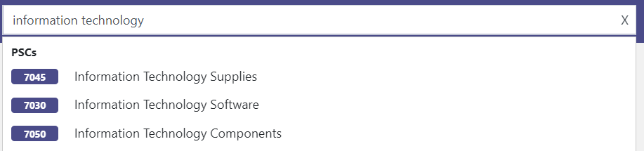

Figure 2b: Searching a PSC by Keyword

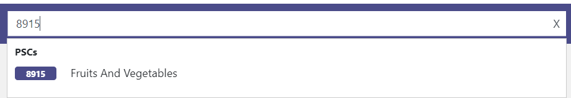

Figure 2c: Searching a PSC by Code Search

B. Spend Categories

Alternatively, the user may search for a PSC by selecting one of the following options: a Spend Category, a category determined by GSA which organizes federal dollars being spent; an OCC, which classifies an object in the context of the government’s budget; or a Better Buying Portfolio group, which is a spend category that was determined by the Under Secretary of Defense for Acquisition, Technology & Sustainment in 2015 (Figure 3).

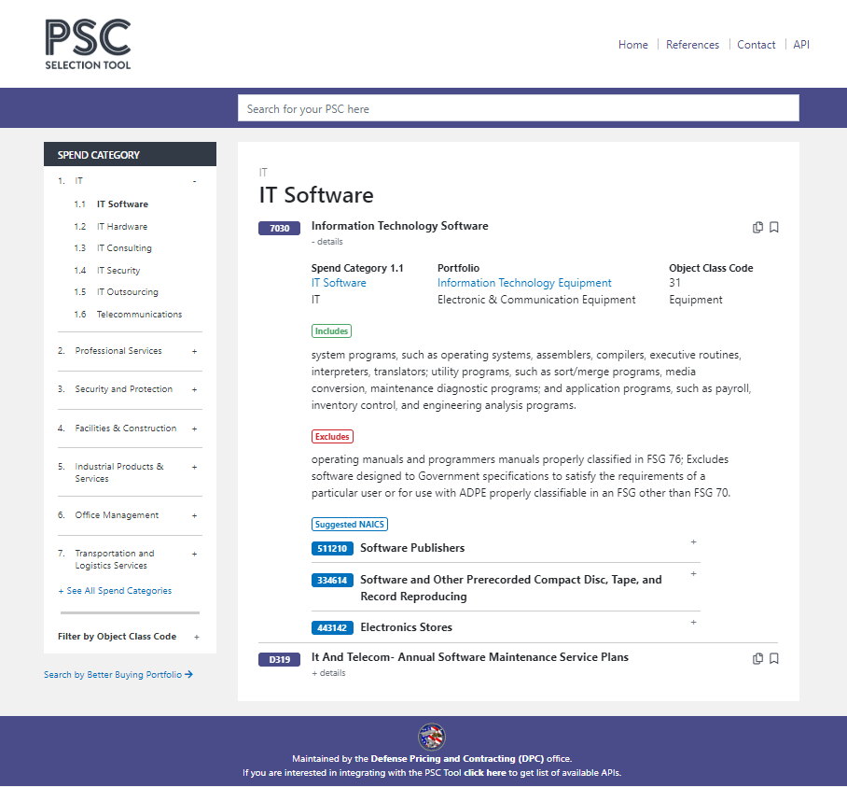

Figure 3: Searching a PSC by Spend Category

The first option presented on the left hand navigation bar is the Spend Category. The user may search for the desired PSC by selecting one of these 19 categories. Upon selection, the category will provide a series of subcategories which contain their own unique set of PSCs. The user can then select the PSC of interest, and view its unique description, spend category classification, portfolio classification, OCC, and materials or items associated with the PSC displayed.

Furthermore, the information presented will show which items are excluded from the PSC examined, and will present a list of suggested NAICS codes that are associated with the PSC. The user may then click on a NAICS code to view its description, which will provide more information about the selected item (Figure 4).

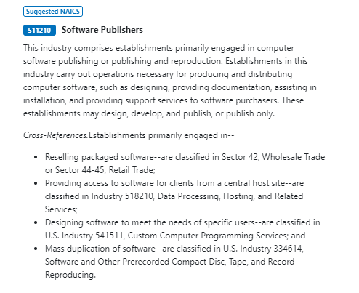

Figure 4: A NAICS Code Description

C. Object Class Code

Alternatively, the user may search for a PSC by selecting the “Object Class Code” option. In order to access this feature, the user will click on the “+” button listed by “Filter by Object Class Code.” Sixteen different OCCs will then appear on the screen (Figure 5).

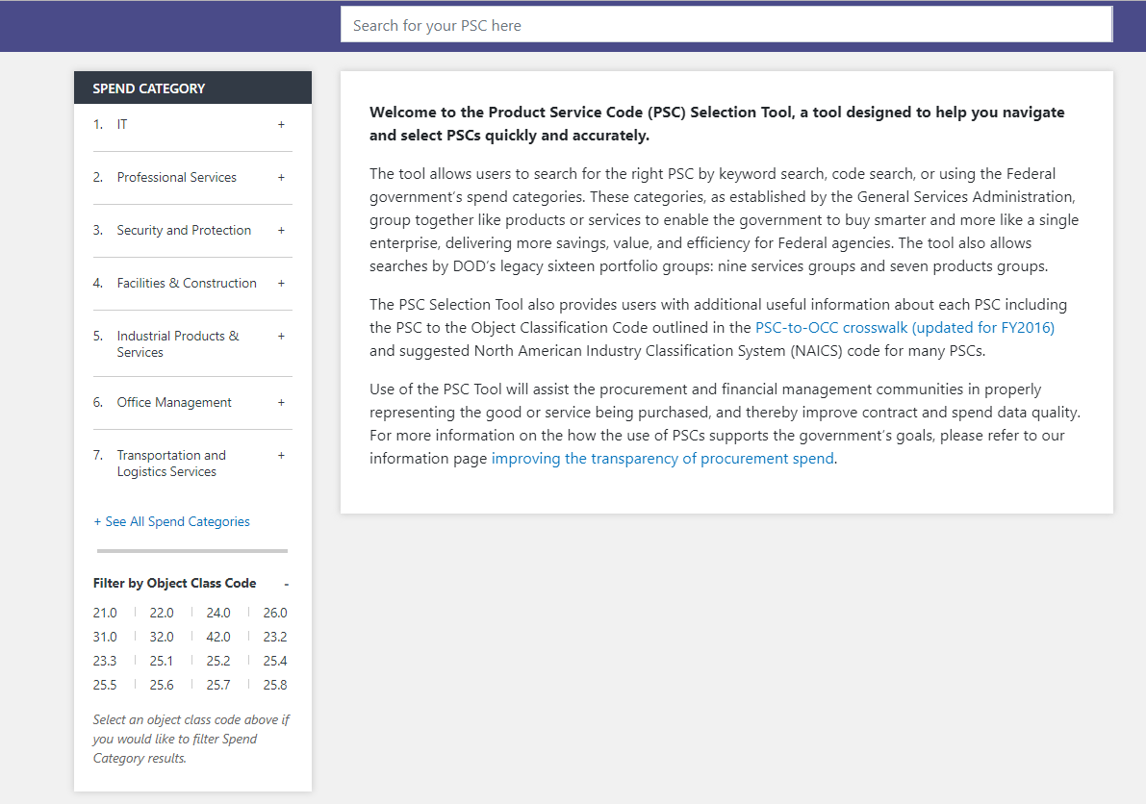

Figure 5: Searching a PSC by OCC

Upon selecting an OCC, the spend categories will filter down to only the related groups. For example, if the user were to select OCC 21.0, only Spend Categories 7 and 8 will appear at the top left hand side of the screen. The user will need to select a spend category to search for the PSC in question, which will bring the user back to the series of PSCs associated with each subcategory within the Spend Category field.

For more information on finding PSCs organized by their respective spend categories, please see Section III.B of this user guide.

D. Better Buying Portfolio

Finally, the user may choose to search for a PSC by DoD’s legacy Better Buying Portfolio groups (Figure 6). These can be found by clicking the “Search by Better Buying Portfolio” link at the bottom of the left hand navigation bar.

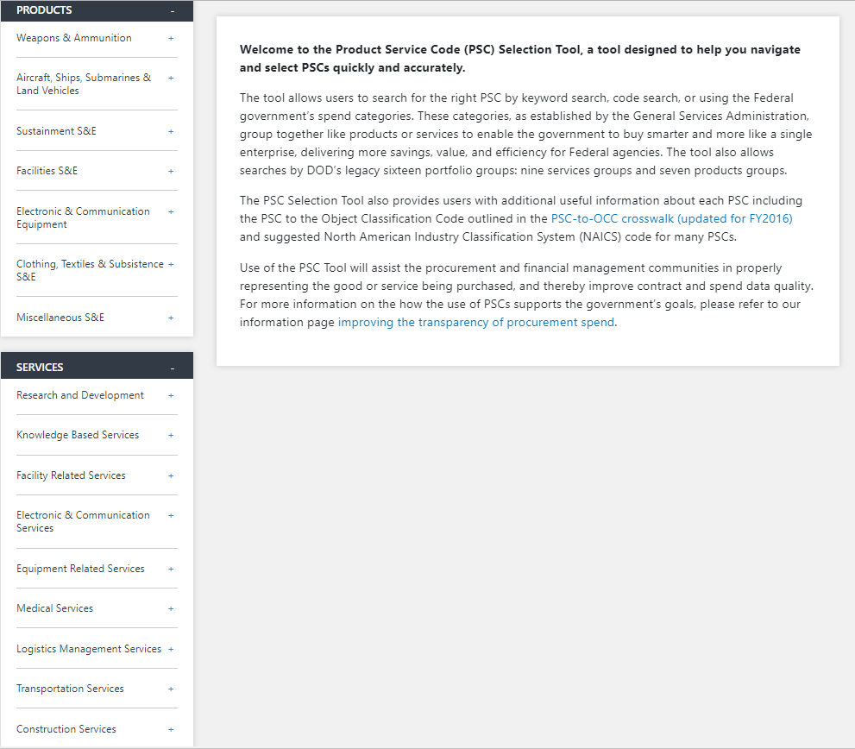

Figure 6: Searching a PSC by Better Buying Portfolio

The Better Buying by Portfolio selection will divide PSCs into two categories: products, which contain items such as weapons, electronic equipment and clothing; and services, which include medical services, transportation services, and construction services. The user will select a subcategory listed under products or services to obtain more information.

Upon selection, a PSC will appear, outlining its description, spend category, portfolio, and OCC. If applicable, a list of NAICS associated with the selected PSC will also appear. The user may then retrieve this information and record it into their respective contract line items (Figure 7).

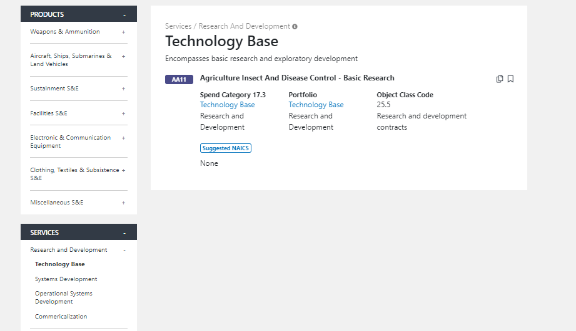

Figure 7: A Detailed View of a PSC Selected from the Better Buying Power Portfolio Option

IV. References

Should the user need any additional resources pertaining to PSCs and their classifications, the user may access the reference page at the top right hand corner of the screen (Figure 8). Selecting “References” will bring the user to the reference page.

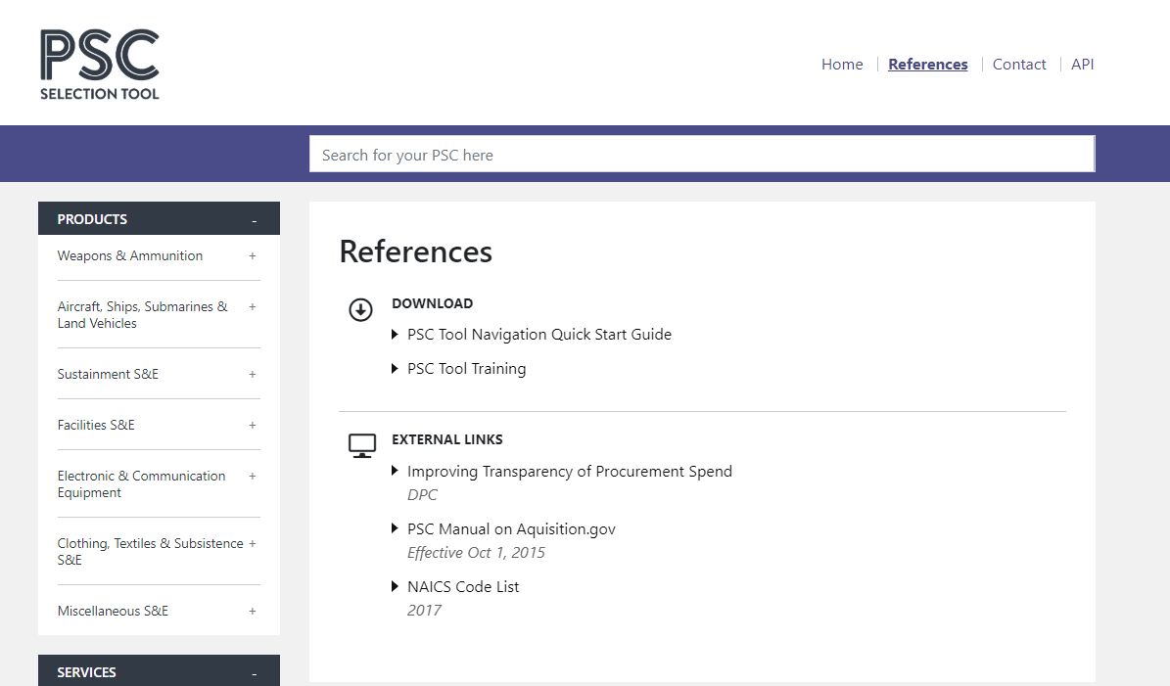

Figure 8: PSC Selection Tool Reference Page

The website will prompt the user to a series of references pertaining to PSC selections. These sources include this PSC Navigation Guide, the PSC Quick Start Guide, and several external links provided by DoD’s Defense Pricing & Contracting Office as well as its partners.

V. Contact

Should the user have any additional questions that cannot be answered by the PSC Selection Tool or the set of materials listed under “References,” the user may contact the PSC Selection Tool Help Desk (Figure 9). The user can access this page by selecting “Contact” at the top right hand corner of the screen.

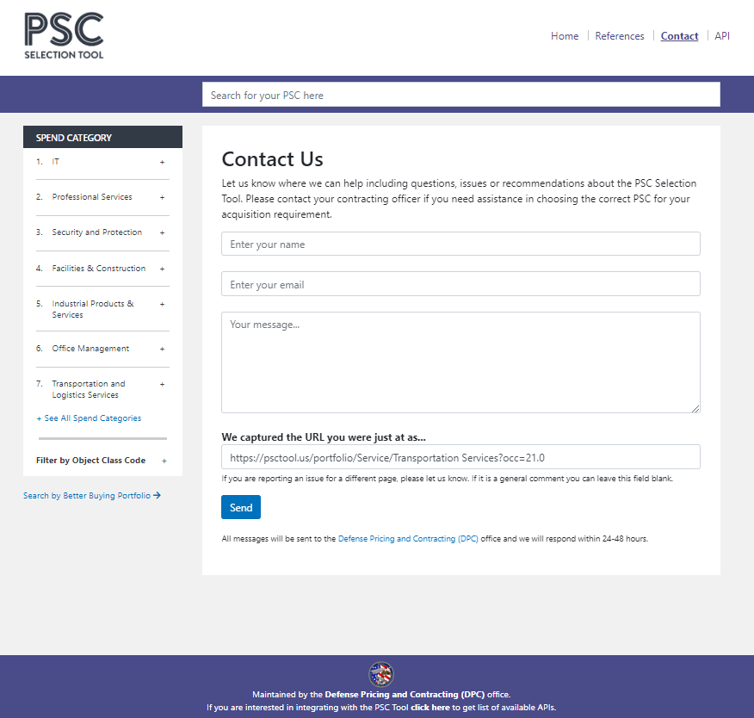

Figure 9: PSC Selection Tool Contact Page

The page will prompt the user to input his or her inquiry into a text box. The user will be required to provide his or her name and email address. Following submission, a member of the PSC Selection Tool Help Desk will respond to the user’s request.

VI. APIs/Integration

Finally, should the user need to access the application programming interface (API) for the PSC Selection Tool, he or she may do so by selecting the “API” option at the top right hand corner of the screen (Figure 10).

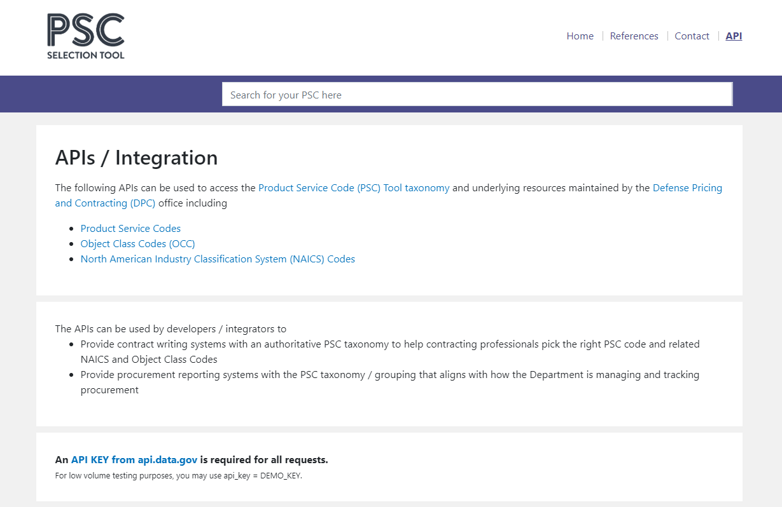

Figure 10: PSC Selection Tool API Page

The API is a set of definitions to help define the interaction between two systems or components. Through the API, the system will allow external systems to pull PSCs, OCCs, and NAICS codes in the PSC Tool taxonomy. These APIs will allow developers and integrators to provide contract writing systems with an authoritative PSC taxonomy.

To complete this function, an API key from https://api.data.gov/signup/ is required.

VII. Conclusion

The PSC Selection Tool will give U.S. DoD leadership greater visibility into the PSC taxonomy and the categorization associated with each PSC.

By outlining the various PSC categories, as well as providing the PSC-to-OCC and PSC-to-NAICS crosswalks, the user will be able to access this information with ease. With the help of this user guide and by navigating the PSC Selection Tool, the user can record the appropriate PSC code when completing contract line items. This, in turn, will result in more accurate and complete contracts.

For more information, please read U.S. General Services Administration and Federal Acquisition Services, Federal Procurement Data System: Product and Service Codes Manual, June 2019, https://www.acquisition.gov/sites/default/files/page_file_uploads/PSC_Manual_June_2019_Edition_6%20_20_19%20%281%29.pdf.
The Office of the Under Secretary of Defense (OUSD) for Acquisition, Technology & Logistics has since been renamed to OUSD for Acquisition & Sustainment.

